Page – Digital Skill Programs
- Main page

  - Change Name to Digital Skill Programs
  - Tag: On-demand digital training designed for real-world skill building
  - Add:
    - Free or paid on each program
  - Filter Section (Dropdown):
    - Skill Level
    - Platform
    - Technology
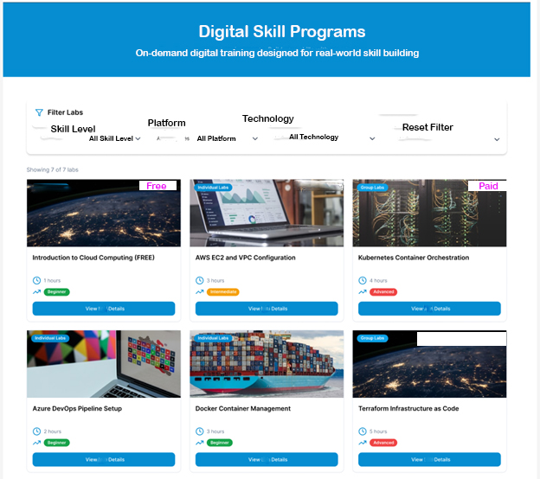
- Sub page for Each Digital Program Labs
Sub Page – Digital Skill Program
Each page show (once click on View Details)
  - Program Name: Editable section to give name
  - First single line to show:
    - Skill Level: Beginner/ Intermediate/ Advance/ Expert
    - Platform: Linux/ Windows/ AWS/ Azure/ GCP/ Hybrid / Multi-Cloud
    - Technology: Administration/ Cloud Computing/ Big Data/ AI / ML/ DevOps/ Security/ Networking
  - Second single line to show:
    - Rating (with icon): Editable section to give number
    - Enrollments Count (with icon): Editable section to give number
  - Third single line to show:
    - Duration (with icon): Editable section to write hours in numbers
    - Language (with icon): Editable section to give Language of training delivery
    - Fees (with icon): Editable section to give fees (Option to show standard fees and Discounted fees (if applicable))
  - Image: Editable section to add image
  - Video: Editable section to upload video (about intro of lab, means what they learn)
  - Description:
    - Write text
    - Option to add icons and give details
  - Lab:
    - Buy the Lab access separately if want to perform hands-on lab (if applicable)
Note: Without buying digital programs, user can only view upto this one.
Recorded Videos only unlocked once purchased the program.
  - Program Overview:
    - Write text
    - Option to add icons and give details
  - Objectives:
    - Write text
    - Option to add icons and give details
  - Pre-requisites:
    - Write text
    - Option to add icons and give details
  - Show Videos:
    - Module 1:
      - Write text
      - Video Section
    - Module 2:
      - Write text
      - Video Section
  - Lab Completion:
    - Button to show Completed successfully (Once user click on Button successfully and auto Certificate or badge generated and mailed to user)
    - Rating: dropdown option to give rating from 1 to 5 (only admin can see)
    - Feedback: Give feedback (only admin can see and get email)
On the left of the page:
  - Box 1: Enroll Now

